Principles of Diagnostic Medicine I · Exam 2 — Study Guide
Editable Word copy of the PA_Quizzes study aid. Headings use real Word styles, so the navigation pane and the contents field below both work, and restyling one heading restyles them all.
[In Word: right-click here and choose Update Field to build the contents.]

★ PROFESSOR EMPHASIS
★ How this exam is written
Three lecturers' rules carry into Exam 2. None of them is new; all of them change how you study.
The rule | What it means for you
“I’m not going to just throw a random number at you and not give you context of whether that’s high or low.” (Professor Reynolds, Lecture 1) | Reference ranges are supplied. A troponin, a triglyceride or a C-reactive protein in a stem will come with the limit that reads it. Learn what a value means.
“Although a heart rhythm can be a diagnosis, you also need to be able to interpret an EKG (electrocardiogram) by naming the rhythm.” (Lecture 1) | Electrocardiography is the one place where naming the finding is fair game. Lecture 7 is the foundation for that: paper, leads, rate, intervals.
Questions are vignette and next-best-test: “what would be the next test that you would order?” | Lecture 8 is built for exactly this. Know what each modality can and cannot show, and what you do when a study is equivocal.

7 · Principles of Electrocardiography
Ayelet Elwaya, MSHS, PA-C, CAQ-EM · 15 September 2026
INSTRUCTIONAL OBJECTIVES
Topic Outline 7: Principles of Electrocardiography
- Describe action potentials and impulse conduction through the cardiac conduction system.
- Define depolarization and repolarization.
- Define absolute and relative refractory periods.
- Describe the fundamental principles of electrocardiography, including: i. Time · ii. Voltage · iii. Vectors · iv. Bipolar leads · v. Unipolar leads
- Identify the standard limb and precordial leads and their proper anatomical placement.
- Determine heart rate using an electrocardiogram.
- Measure and interpret: i. PR interval · ii. QRS duration · iii. QT interval · iv. QTc interval
- Identify normal electrocardiographic intervals and waveforms.

★ PROFESSOR EMPHASIS
★ Professor emphasized — 15 September recording
She said | So
“I will not be testing you on calcium channels and funny sodium channels and all that good stuff because you’ve done that in physiology.” But an electrolyte she uses on a slide “is” fair game. | Know which ion moves in each phase, not the channel subtypes.
“Yes, you need to know what happens in each phase.” | The five-phase table in 7.1 is examinable as written.
The refractory periods are “very important from now until forever.” | They explain R-on-T, P-on-T and why a prolonged QTc is dangerous.
Lead placement: “I am sorry, you do have to memorize this.” And bipolar versus unipolar, precordial versus limb: “you have to know the distinction.” | 7.4 and 7.5 are memorization, not reasoning.
“It’s very important that you know how to identify the J point.” | ST elevation is measured from it (see 7.7).
Bazett’s formula: “please do not memorize. I will never ask you about the formula.” The bifascicular-block aside: “I will not ask you this on the test.” | Know that the QTc is the rate-corrected QT and its thresholds, not how it is computed.

7.1 · Objective a — The action potential and the conduction system
Four properties make a cardiac cell a cardiac cell: automaticity (it produces its own impulse), excitability (it responds to an impulse or stimulus), contractility (it contracts) and conductivity (it passes the impulse from myocyte to myocyte).
The action potential is a rapid change in voltage across the cell caused by ion movement. It has five phases, and the sequence starts at phase 4: 4 → 0 → 1 → 2 → 3.
Phase | Name | What happens
4 | Resting state (diastole) | Cell is ready to respond. More potassium inside; sodium and calcium outside. Inside voltage −90 mV.
0 | Upstroke (depolarization) | Fast sodium channels open; rapid sodium influx makes the inside positive.
1 | Early repolarization | Sodium channels close and potassium channels reopen; a slight negative shift.
2 | Plateau | Calcium enters, causing contraction, balanced by potassium moving the other way, so the voltage holds level.
3 | Rapid repolarization | Calcium channels close; potassium channels stay open; the inside returns to −90 mV.

NOTE
A slide and its own figure disagree on direction. The text of slides 9 and 10 describes potassium as moving into the cell during phases 2 and 3. The figure on the same slides (below) labels it potassium efflux, which is the physiology: potassium leaves the cell to repolarize it. Learn it as potassium out, calcium in, during the plateau.

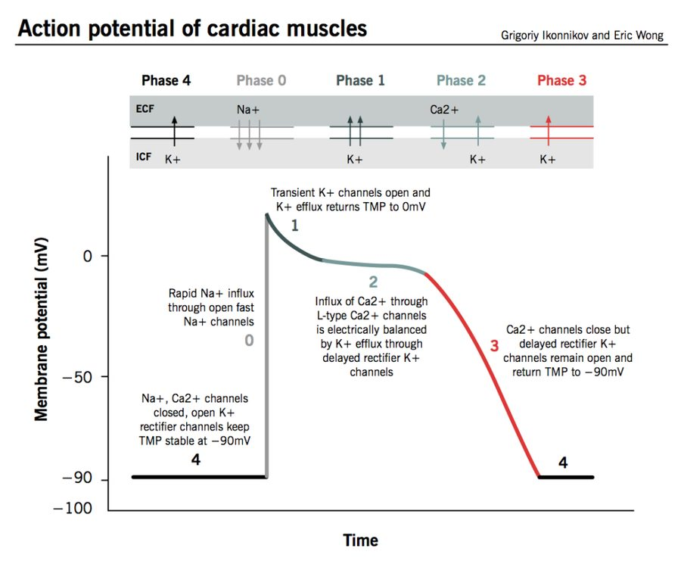
The five phases on one trace. Read the ion arrows along the top: sodium in at phase 0, calcium in and potassium out during the phase 2 plateau, potassium out through phase 3. The flat line at −90 mV is phase 4, both the end of one cycle and the start of the next. Source: Principles of Electrocardiography.pptx, Slide 4.
Also tested
- Relative refractory period. Unlike the absolute period, a sufficiently strong stimulus can produce a response. The cell is excitable but not fully recovered, so a stimulus arriving then can start something abnormal.
- Right bundle branch. It is much longer than the left, despite the left ventricle being the larger chamber; the anatomy does not follow chamber size.
- Phase 3, rapid repolarization. Calcium channels close while potassium channels remain open, returning the cell to minus ninety millivolts; the inward current stops and the outward one continues unopposed.
- Absolute refractory period. It runs from phase 0 to the middle of phase 3 and lasts about a hundred and eighty milliseconds, during which no stimulus of any strength will produce another action potential.
- Depolarization and contraction. Depolarization represents activation of cardiac tissue, and it precedes contraction; the electrical event comes first, so an electrocardiogram showing depolarization does not prove the muscle actually contracted.
- Membrane during depolarization. The membrane becomes less negative, moving away from its resting negativity.

The conduction system
A network of specialized muscle cells that generate and spread the signal so the heart beats in a coordinated rhythm. Each level can take over pacing if the one above fails, at a slower intrinsic rate.
Structure | Where | Key facts | Intrinsic rate
Sinoatrial node | Upper wall of the right atrium, just below the vena cava opening | Main pacemaker. Three internodal pathways to the atrioventricular node: superior anterior (fast, used by the majority), middle, and inferior posterior (slow). The other two usually terminate before reaching the atrioventricular node. | 60–100 per minute
Atrioventricular node | Junction of atria and ventricles, near the coronary sinus | Introduces a short pause and amplifies the signal. Back-up pacemaker if the sinoatrial node fails. | 40–60 per minute
Bundle of His | Crosses the nonconductive atrioventricular septum | In a normal heart, the only electrical pathway from atria to ventricles. | —
Left bundle branch | Into the left ventricle | Splits into three fascicles: left posterior, intraventricular septal, and left anterior (which becomes the Purkinje network). | —
Right bundle branch | Into the right ventricle | Much longer than the left despite the smaller ventricle; terminates in the Purkinje network. | —
Purkinje network | Ventricular walls | Third pacemaker if both nodes fail. Conducts faster and more efficiently than any other part of the system. | 20–40 per minute

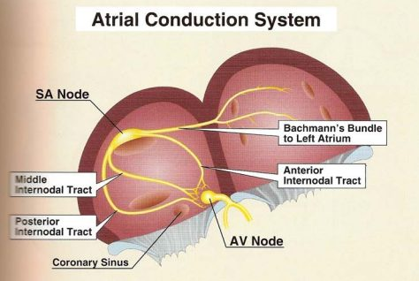
The atrial half of the system. The sinoatrial node sits high in the right atrium; the internodal tracts carry the impulse down to the atrioventricular node beside the coronary sinus, where it pauses before the bundle of His. Source: Principles of Electrocardiography.pptx, Slide 13.
A bifascicular block is not the same as a left bundle branch block (slide 16). She said this will not be tested beyond that distinction.
The cardiac vector is the arrow showing the direction and strength of current at any moment. The true pathway of conduction is left and down, toward the anterior chest.

7.2 · Objective b — Depolarization and repolarization
 | Depolarization | Repolarization
Membrane | Becomes less negative | Returns toward its resting state
Represents | Activation (excitation) of cardiac tissue | Recovery of the cells
Timing | Precedes contraction | Follows it
On the tracing | P wave (atria), QRS complex (ventricles) | T wave (ventricles)

Depolarization is electrical, contraction is mechanical, and the electrical event comes first. This is also why an electrocardiogram cannot tell you whether the patient has a pulse (7.4).

7.3 · Objective c — Absolute and relative refractory periods
 | Absolute refractory period | Relative refractory period
Definition | The cell will not respond to another stimulus | The cell will respond to a second stimulus, but it is very fragile
Span | Phase 0 to mid phase 3 | Mid phase 3 to the end of phase 3
Duration | Typically about 180 ms | —
On the tracing

NOTE
Why it matters. A beat that lands in the relative refractory period, before the previous one has finished, is the mechanism behind the dangerous patterns you will meet later: R on T, P on T and a prolonged QTc are all risk factors for a beat hitting before the last one ended.

7.4 · Objective d — Time, voltage, vectors, bipolar and unipolar leads
An electrocardiogram is a visual representation of cardiac electrical activity over time. The direction of current is compared with a stationary electrode: a positive overall vector gives an upward deflection, a negative one a downward deflection, and a net zero traces only the isoelectric line.
Axis | Small box | Large box (5 small) | Other
Time (left to right) | 0.04 seconds | 0.2 seconds | 5 large boxes = 1 second. Strips are usually 3 or 6 seconds.
Voltage (up and down) | 1 mm = 0.1 mV | 5 mm | Standard calibration: 10 mm (two large boxes) = 1 mV.

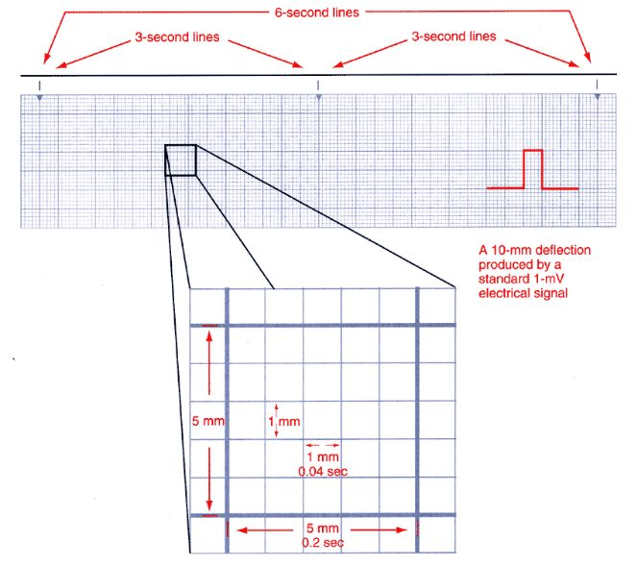
Paper is the ruler for every measurement in this lecture. Small box 0.04 seconds, large box 0.2 seconds, and the 3-second markers along the top are what make the 6-second rate method possible. Source: Principles of Electrocardiography.pptx, Slide 27.
Lead type | What it measures | Which leads
Bipolar | Voltage difference between two body points, one positive and one negative electrode | Leads I, II, III (Einthoven’s triangle: both shoulders and the left lower extremity)
Unipolar | Activity from one electrode reference point | aVR, aVL, aVF (augmented: one physical lead plus a theoretical negative pole created by the machine) and V1–V6

An electrocardiogram CAN tell you | It CANNOT tell you
Whether there is electrical activity · conduction problems · rate · rhythm · where the impulse originates · how much electricity is conducted | Hemodynamic status · cardiac output · whether the patient has a pulse

Also tested
- Lead deflection and vector direction. When the overall vector at a given moment is directed away from a lead, that lead records a negative deflection; toward the lead gives a positive deflection, which is why the same beat looks different in different leads.

7.5 · Objective e — Limb and precordial leads and their placement
Every lead is a different point of view. A standard 12-lead uses 10 physical electrodes: four limb electrodes (right arm, left arm, left leg, plus right leg) and six chest electrodes. The four limb electrodes produce six leads — I, II, III, aVR, aVL, aVF — the hexaxial leads, used to determine the axis. Add V1–V6 and you have twelve views from ten wires.
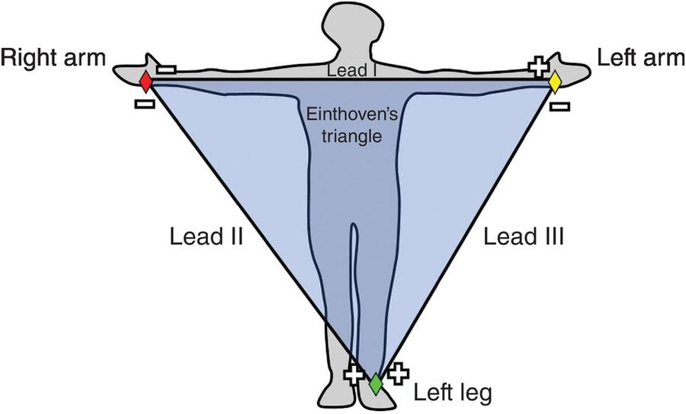
Einthoven’s triangle: the three bipolar leads. Each side of the triangle compares two limb electrodes. Lead II runs from right arm to left leg, along the heart’s own vector, which is why it is the rhythm strip. Source: Principles of Electrocardiography.pptx, Slide 21.
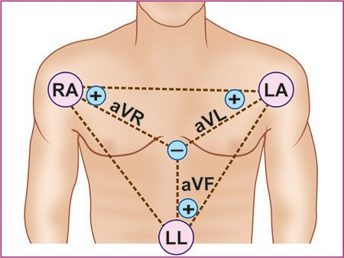
The augmented leads are unipolar. One physical electrode against a negative pole the machine creates in the middle of the chest. Source: Principles of Electrocardiography.pptx, Slide 21.
The precordial (chest) leads give a horizontal view of the heart, with very specific placement:
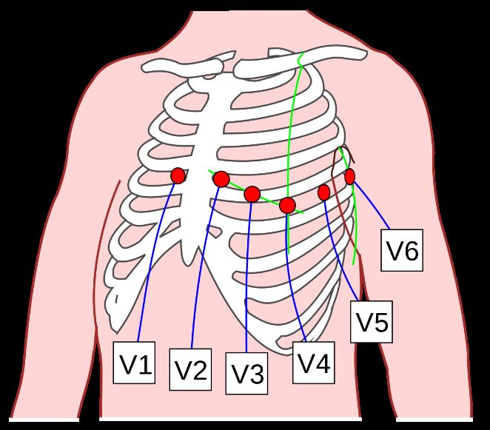
V1 to V6. Placement is one of the things she said must be memorized. V1 and V2 sit either side of the sternum, V4 lower on the left, V3 midway between them, and V5 and V6 continue laterally at the level of V4. Source: Principles of Electrocardiography.pptx, Slide 23.
Lead II has the best view of the heart’s vector, so it is the lead used for rhythm interpretation. The cardiac cycle looks different in other leads.
Contiguous leads look at the same area of the heart: V1, V2, V3, V4 · II, III, aVF · I, aVL, V5, V6.
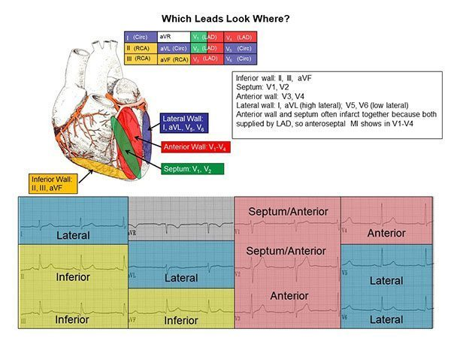
Slide 24 is text-empty; this picture is its content. Inferior II, III, aVF · septum V1–V2 · anterior V3–V4 · lateral I and aVL (high) and V5–V6 (low). The anterior wall and septum often infarct together because both are supplied by the left anterior descending artery, so an anteroseptal infarction shows in V1–V4. Source: Principles of Electrocardiography.pptx, Slide 24.
Also tested
- Contiguous leads. These are two or more leads looking at the same area of the heart, so a change in a contiguous group means more than the same change in one isolated lead.
- Hexaxial reference system. It is used to determine the normal axis of the heart; six views in one plane make an axis calculable.
- Bipolar leads. Leads I, II and III are bipolar, forming the imaginary triangle across the shoulders and the left lower body; everything else on a twelve-lead tracing is unipolar.

7.6 · Objective f — Determining heart rate
Both methods only work if the rhythm is regular, so check regularity first: compare consecutive R to R intervals, with calipers or a marked sheet of paper if in doubt.
Method | How
6-second method | Take a 6-second strip (two 3-second markers, or 30 large boxes). Count QRS complexes and multiply by 10 for the ventricular rate; count P waves and multiply by 10 for the atrial rate.
300 method | Start at an R wave on a heavy line. Each following heavy line counts down: 300, 150, 100, 75, 60, 50. The next R wave’s position gives the rate.

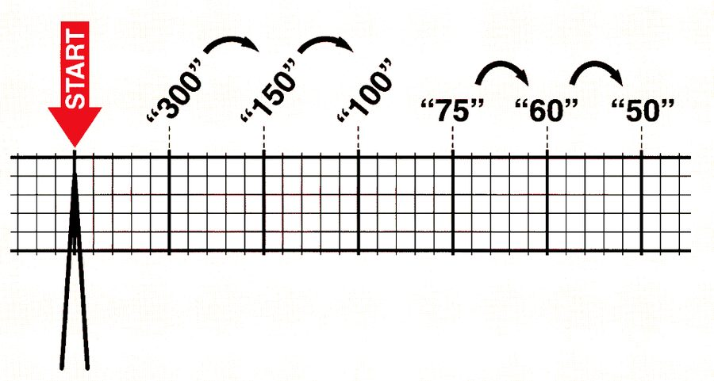
Slide 53 is only this picture. Count down the heavy lines from an R wave on a line: 300, 150, 100, 75, 60, 50. An R wave landing on the third line means a rate of about 100. Source: Principles of Electrocardiography.pptx, Slide 53.
Also tested
- Six-second rate method. Multiply the QRS count in a six-second strip by ten, since six seconds is a tenth of a minute; eight complexes give a ventricular rate of eighty beats per minute.
- Regularity of the rhythm. When not obvious by eye, determine it by comparing consecutive R to R intervals with calipers, or with a marked sheet of paper.
- R to R interval. It is used to assess rate and regularity, and comparing consecutive R to R intervals is the first thing done to a strip.

7.7 · Objectives g & h — Waves, segments, intervals and their normal values
A wave is a deflection from baseline; a segment is the flat line between two waves; an interval spans at least one wave plus one segment. The QRS is the one complex.
Component | Represents | Normal
P wave | Atrial depolarization | Under 0.12 s (3 small boxes); upright in lead II
PR interval | Start of P to start of QRS: atrial depolarization, the atrioventricular node delay and His-Purkinje conduction | 0.12–0.20 s (3–5 small boxes)
QRS complex | Ventricular depolarization | Under 0.12 s; narrow with sharp points. Not every wave appears in every lead.
Q wave | Septal depolarization (first negative deflection after the PR) | Under 0.04 s, low amplitude; not always visible
R wave | Anterior left ventricle (first positive deflection) | —
S wave | Lateral left ventricle (first negative deflection after R) | Must go below baseline to be a true S wave
J point | Junction where the QRS ends and the ST segment begins | At baseline; 1 mm variance allowed
ST segment | Between ventricular depolarization and repolarization; ventricles hold contraction | At baseline
T wave | Ventricular repolarization | 0.16–0.25 s; its peak divides absolute from relative refractory period
QT interval | All ventricular activity: start of QRS to end of T | 350–450 ms in males, 360–460 ms in females
QTc | QT corrected for heart rate (Bazett’s formula, computed by the machine) | Same values as the QT. Above 450 (460 in women) to 500 ms = borderline or prolonged; above 500 ms = high-risk prolongation
U wave | Unclear; possibly Purkinje repolarization. Follows T in the same direction; best in V2–V3 | Prominent in hypokalemia, hypercalcemia, prolonged QT, post-infarction
TP segment | Resting state between T and the next P | The best place to judge the isoelectric line
R to R interval | Distance between consecutive R waves | Used for rate, regularity and heart blocks

Be systematic and consistent. Rhythm → rate → P waves (present, alike?) → a P for every QRS and a QRS for every P → QRS width → PR interval → ST segment → T wave → QTc → any extra waves or beats (fibrillation, sawtooth, U waves, delta waves, premature ventricular contractions) → any voltage concerns.
Source: Principles of Electrocardiography.pptx (Ayelet Elwaya). Emphasis quoted from the 15 September 2026 recording (two segments, about 95 minutes). Slides 24 and 53 carry their content only as pictures and are reproduced above. The practice strips on slides 55–64 are worked examples and are not restated here.
Also tested
- Corrected QT above 500 milliseconds. A corrected QT beyond five hundred milliseconds is high risk prolongation, above the borderline range that begins in the low four hundreds.
- Corrected QT. It is used rather than the raw QT interval because the QT interval changes with heart rate; without correcting, the same heart would show different values at different rates.
- Q wave. It represents depolarization of the interventricular septum, which travels away from lead II and so gives a downward deflection. It is not always visible.
- ST segment. It falls between ventricular depolarization and repolarization, when the ventricles hold their contraction to allow emptying; it is the part of the beat that does the ejecting.
- S wave. A deflection must extend below the baseline to count as a true S wave; if it does not, it is called an S wave pattern instead.
- Prominent U waves. They are associated with hypokalemia, hypercalcemia, prolonged QT and the period after myocardial infarction; the electrolyte associations are the practically useful ones.
- PR interval. It includes atrial depolarization, the delay at the atrioventricular node, and conduction through the His-Purkinje system; as three events in one measurement, a prolonged PR interval does not by itself say where the hold-up is.

8 · Cardiac Imaging and Vascular Studies
Ayelet Elwaya, MSHS, PA-C, CAQ-EM · 17 September 2026
INSTRUCTIONAL OBJECTIVES
Topic Outline 8: Cardiac Imaging and Vascular Studies
- Identify cardiovascular anatomy on radiographic studies.
- Identify structures comprising the cardiac silhouette.
- Identify common abnormal cardiovascular imaging findings.
- Measure the cardiothoracic ratio to evaluate cardiac enlargement.
- Compare and contrast cardiovascular imaging modalities.
- Discuss indications, advantages, and limitations of: i. Echocardiography · ii. Stress testing · iii. Nuclear cardiology studies · iv. Cardiac CT · v. Cardiac MRI · vi. Coronary angiography · vii. Vascular ultrasound

★ PROFESSOR EMPHASIS
★ Professor emphasized — 17 September recording
She said | So
The gold standard to diagnose coronary artery disease — “that was a high-miss last year” — is “to put a catheter in the coronary artery.” | Coronary angiography is the gold standard, even though a computed tomography angiogram can show the calcification.
“If I give you a test question about someone who needs an echo to see their left atrial appendage” and they have a history of esophageal stricture, “scratch that answer out.” | Know the transesophageal echocardiogram contraindications, and what the transthoracic study cannot see.
“I do want you to remember that your predicted heart rate is 220 minus your age.” | And that a valid test reaches 85% of it. How the numbers were derived is not needed.
A patient who “couldn’t hit” their target heart rate and stopped early without chest pain: “What is the next best step … A cardiac CTA (computed tomography angiogram)!” | An equivocal or non-diagnostic stress test is an indication for coronary computed tomography angiography.
“The main indication for a left heart cath is to visualize your coronary arteries — take a highlighter, circle it — the main reason you would want to do a right heart cath is for people you are assessing for pulmonary hypertension.” | One indication each, circled.
After a positive computed tomography angiogram with left anterior descending disease, the next step is the catheter, “because intervention is done according to percentage.” | Noninvasive tests say whether disease is there; angiography says how much.
On the exercise endpoint chart: “Do not memorize” the order, “but understand what this chart is saying … these are indications to stop the test.” The treadmill protocol tables are not for memorizing. | Know why a test is stopped, not the table layout.

8.1 · Objectives a & b — Cardiovascular anatomy and the cardiac silhouette
The chest radiograph is not the primary modality for cardiac function or detailed anatomy, but when one is obtained it gives important clues. Partially visible: the cardiac silhouette, great vessels, pulmonary vasculature, and lungs and pleura.
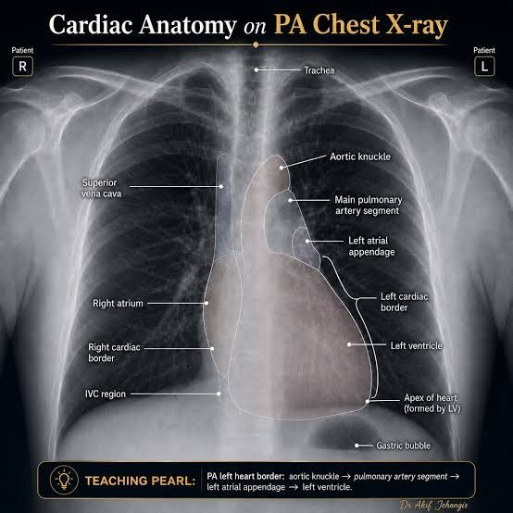
Slide 5 has no text; the labels are in the pictures. Right border: superior vena cava above, right atrium below. Left border, top to bottom: aortic knuckle → main pulmonary artery segment → left atrial appendage → left ventricle , with the apex formed by the left ventricle. Source: Cardiac Imaging and Vascular Studies - Elwaya.pptx, Slide 5.
Border | Structures, top to bottom
Right heart border | Superior vena cava → right atrium (inferior vena cava region at the base)
Left heart border | Aortic knuckle (arch) → main pulmonary artery → left atrial appendage → left ventricle → apex

Also tested
- Chest radiography in cardiac evaluation. It is not the primary modality, but it gives useful clues when obtained; it is frequently the study already in hand, so reading it well matters.

8.2 · Objective c — Common abnormal findings
Chest radiograph abnormalities that can indicate cardiac pathology:
Finding | Note
Pulmonary edema · pleural effusion | The heart shows itself through the lungs
Cardiomegaly | Judged by the cardiothoracic ratio (8.3)
Cephalization | Upper-lobe vessels become larger and more prominent than the lower ones. Seen in heart failure and pulmonary hypertension.
Calcification | Great vessel, valvular, or pericardial
Tension physiology | Pneumothorax causing tamponade

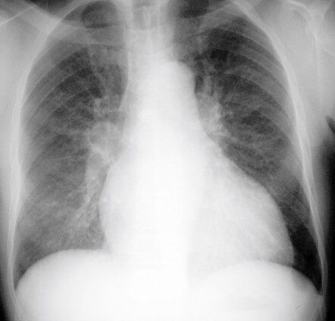
Cephalization. The upper-zone vessels are as prominent as, or more prominent than, the lower ones — the reverse of normal. Think heart failure or pulmonary hypertension. Source: Cardiac Imaging and Vascular Studies - Elwaya.pptx, Slide 9.
Also tested
- Vascular ultrasound appearance. The denser the structure, the lighter it appears, so air is black and bone is near white. Superficial structures sit nearer the top of the screen.
- Chest radiograph indicators of cardiac pathology. They are edema, effusion, cardiomegaly, cephalization and calcification, with tension physiology completing the list; the calcification may be of the great vessels, the valves or the pericardium.
- Vascular ultrasound image formation. Quartz crystals emit high frequency pulses that reflect off tissue; the returning echoes are turned into a picture, what returns depends on the density of what the pulses meet, and anything that stops sound returning leaves a gap.
- Coronary arteries and vascular ultrasound. Assessment of coronary artery stenosis is not a listed indication for vascular ultrasound: the coronary arteries are not accessible to surface vascular ultrasound and are assessed by computed tomography angiography or catheter angiography.

8.3 · Objective d — The cardiothoracic ratio
Widest cardiac diameter divided by the widest internal thoracic diameter. Normal 0.42–0.5. A ratio above 0.50 on a properly performed posteroanterior film suggests cardiomegaly — the silhouette should occupy no more than about half the thoracic width.
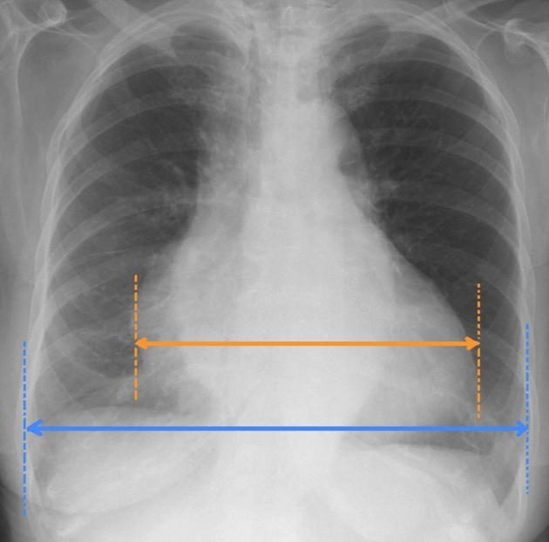
How the ratio is measured. Orange: the widest cardiac diameter. Blue: the widest internal thoracic diameter. Orange over blue above 0.5 on a proper posteroanterior film suggests cardiomegaly. Why posteroanterior matters comes from Lecture 2: an anteroposterior film magnifies the heart. Source: Cardiac Imaging and Vascular Studies - Elwaya.pptx, Slide 8.

8.4 · Objective e — Comparing the modalities
Modality | Best at | Cannot / against
Chest radiograph | Clues when already obtained: silhouette, vessels, lungs | Not for function or detailed anatomy
Vascular ultrasound | Vessels and flow, no radiation, portable, repeatable | Operator dependent; habitus, bone and air limit it; deep vessels hard
Echocardiography | Structure and function together, bedside | Transthoracic view poor for the posterior heart; transesophageal is invasive
Stress testing | Inducible ischemia and functional capacity | Invalid if 85% of predicted maximum is not reached
Nuclear perfusion | Ischemia versus viability; more accurate than standard or echo stress | Radiotracer
Cardiac computed tomography and angiography | Anatomy, calcium, noninvasive coronary assessment; superior resolution to echo | Anatomy only, not function; radiation, contrast, rate dependent, blooming
Cardiac magnetic resonance | Detailed anatomy and function, viability, inflammation; no ionizing radiation or iodinated contrast | Implants, long acquisition, claustrophobia
Coronary angiography | Gold standard for coronary anatomy; can treat during the study | Invasive: hematoma, pseudoaneurysm

8.5 · Objective f.i — Echocardiography
Noninvasive evaluation of chamber size, atrial and ventricular function and wall thickness, ejection fraction, blood flow and velocity with Doppler, valve structure and function, and intracardiac shunts, hemodynamics and pressures.
 | TTE (transthoracic echocardiogram) | TEE (transesophageal echocardiogram)
Transducer | Outside the body, on the chest wall | Inside, on a modified endoscope in the esophagus
Use | Most common; bedside and noninvasive | When more structural detail is needed, particularly the inferior and posterior heart
Procedure | Left lateral decubitus, gel, probe over several windows | Left lateral decubitus; topical anesthetic to the throat; intravenous sedative; electrocardiogram and vital-sign monitoring; patient may swallow to pass the probe

The transesophageal study sees in more detail: left atrium, mitral valve, pulmonary artery, aorta, coronary arteries. When to use it: aortic and great-vessel disease (dissection, dilation, arteritis), cardiac tumor (myxoma), prosthetic valve function, valve vegetations, cerebral ischemia, and left atrial appendage thrombus.
NOTE
TEE (transesophageal echocardiogram) contraindications — anything the probe could injure or an airway you cannot protect: altered mental status or an uncooperative patient · esophageal stricture, malignancy, or varices with recent bleeding · odynophagia or dysphagia history · Zenker’s diverticulum (identify with a swallowing study first) · cervical spine arthritis with reduced range of motion · obstructive sleep apnea or airway risk.

Also tested
- Transthoracic echocardiography. It is the most common echo procedure because it can be performed at the bedside and is noninvasive. Availability, not image quality, makes it the default, and the trade is detail at the back of the heart.
- Transesophageal echocardiography. Unlike the transthoracic study, it requires throat anesthesia, sedation and monitoring. It is a procedure rather than a scan, so it carries a contraindication list.
- Contraindications to a transesophageal study besides esophageal disease. An uncooperative patient or altered mental status, restricted neck movement (cervical spine arthritis with reduced range of motion), and airway risk (obstructive sleep apnea or other risk of airway compromise).
- Transesophageal study in cerebral ischemia. It can find thrombus in the left atrial appendage, looking for the source rather than the consequence; the appendage is the site the transthoracic study sees worst.
- Zenker's diverticulum before a transesophageal study. It must be identified first because the probe risks entering and perforating the pouch; being a pouch rather than a narrowing, the operator may feel nothing wrong until the damage is done.

8.6 · Objective f.ii — Stress testing
Four types: standard exercise, echocardiography, nuclear, and pharmacologic.
The exercise tolerance test assesses functional capacity and indirectly detects ischemia through continuous electrocardiogram monitoring — ST depression or new premature ventricular contractions. Treadmill or stationary cycle (bicycle preferred; arm ergometry exists), run to a protocol, usually Bruce. Complications: arrhythmia, angina, infarction, death.
NOTE
Validity. The patient must reach at least 85% of predicted maximal heart rate, where predicted maximum = 220 minus age. Below 85%, an otherwise negative test is inadequate to exclude ischemic heart disease.

Indications | Procedure
Symptoms suggesting ischemia (exertional chest pain) · acute chest pain once acute coronary syndrome and infarction are excluded · known ischemic disease with a change in status · prior revascularization · new heart failure or cardiomyopathy · certain arrhythmias · preoperative assessment of a high-risk patient before non-cardiac surgery | Resting electrocardiogram and blood pressure (supine and standing) → exercise increased by metabolic equivalents → blood pressure in the last minute of each stage → watch face, color, tracing and pressure → stop at maximum performance, ischemic signs or symptoms, or a predetermined endpoint

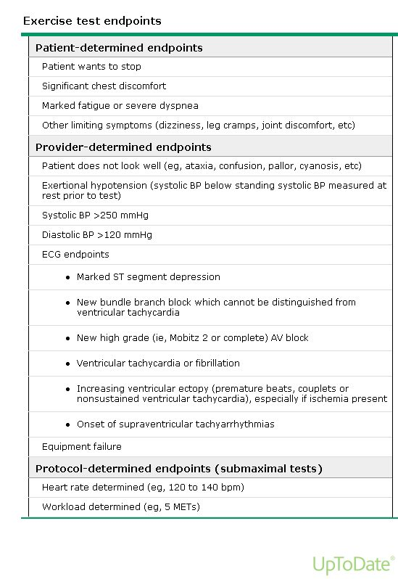
Why a test is stopped. Understand the categories rather than the order: the patient stops it (chest pain, dyspnea), the provider stops it (looks unwell, exertional hypotension, extreme pressures, dangerous rhythms, marked ST depression), or the protocol stops it. Source: Cardiac Imaging and Vascular Studies - Elwaya.pptx, Slide 36.
Variant | For whom | Key point
Echocardiography stress | Can exercise, but baseline electrocardiogram abnormalities (ST-T changes) would confuse interpretation | Echo immediately after exercise, while the heart is still fast, looking for new wall-motion abnormality
Pharmacologic stress | Cannot exercise (for example wheelchair dependent) | Adenosine or dipyridamole vasodilate the coronaries; dobutamine increases cardiac workload

Also tested
- Echocardiographic stress test. It is the appropriate initial choice for a patient who can exercise but whose resting tracing is abnormal, since the electrocardiogram cannot be read for ischemia if already abnormal and imaging must carry the answer.
- Post-exercise echocardiogram. It looks for abnormal left ventricular wall motion induced by exercise. The finding is transient and resolves as the heart recovers, so the patient dismounts quickly and is imaged promptly.

8.7 · Objective f.iii — Nuclear cardiology
A small amount of radioactive perfusion tracer is injected and taken up by the heart. It assesses ischemia, myocardial blood flow, pumping function, and the size and location of an infarction.
Myocardial perfusion imaging pairs rest images with images after exercise or pharmacologic stress (adenosine, dobutamine), read by a gamma camera (single-photon emission computed tomography) or positron emission tomography. Diseased myocardium receives less flow under stress, so less tracer uptake after stress means a blockage or vasospasm. Tissue that does not light up at all is dead — which is how it shows viability.
More accurate than standard and echocardiography stress testing for detecting ischemia; its sensitivity and specificity are superior. Indications: diagnosing coronary disease in acute or stable chest pain, locating and grading known disease, and prognosis.
Also tested
- Nuclear stress pattern. Tracer uptake that is normal at rest but reduced after stress indicates inducible ischemia from a coronary stenosis: the tissue is alive but cannot increase its supply when demand rises.

8.8 · Objective f.iv — Cardiac CT (computed tomography) and CT angiography
Computed tomography optimized for the heart, coronaries, chambers, valves, pericardium and great vessels. Coronary computed tomography angiography evaluates the coronary arteries; non-contrast cardiac computed tomography is used for coronary artery calcium scoring. Because the heart moves, metoprolol slows it and nitroglycerin dilates the coronaries, and the scan is gated to the electrocardiogram.
Computed tomography angiography indications | Cardiac computed tomography indications
Chest pain: presence and distribution of coronary disease · detect or exclude stenosis or plaque · equivocal or non-diagnostic stress test | Coronary calcium · coronary anatomy anomalies · congenital heart disease · preoperative planning (valves, great vessels); usually done right before a computed tomography angiogram
Advantages | Disadvantages
Superior resolution to echocardiography · internal structures · noninvasive coronary assessment · fast | Radiation · contrast (kidney disease) · rhythm and rate dependent · blooming artifact overstates calcification · anatomy only, not function

Also tested
- Cardiac computed tomography preparation. Cardiac medications are given to control heart rate, since the moving heart degrades the images. The study is also synchronized to an electrocardiogram so the heart can be examined at chosen points in the cycle.
- Blooming artifact. Heavy calcification appears larger than it is on cardiac computed tomography, so a stenosis looks more severe; it exaggerates the very lesion the study was ordered to assess.
- Cardiac computed tomography indications. Pre-operative planning before cardiac surgery, particularly valvular and great vessel procedures, is an indication, alongside calcium deposits, coronary anatomical anomalies and congenital disease. It is usually done immediately before the angiographic study.
- Limitation of cardiac computed tomography. Compared with echocardiography and magnetic resonance, it assesses anatomy but not function: it shows structure in great detail but cannot tell how well it is working, which decides when it is the wrong study.

8.9 · Objective f.v — Cardiac MRI (magnetic resonance imaging), now cardiovascular magnetic resonance
Magnetic fields and radiofrequency map hydrogen into three-dimensional images of the heart and great vessels, with very detailed anatomy. It assesses anatomy (mainly muscle), ventricular function, great vessels, coronary anatomy, flow, viability, perfusion and inflammation — without ionizing radiation or iodinated contrast.
An echocardiogram is done before it is ordered. Indications: thoracic aorta (aneurysm, dissection, intramural hematoma, coarctation) · congenital heart disease (coronary anomalies, shunt quantification) · cardiomyopathies (hypertrophic, ischemic versus nonischemic, acute myocarditis, sarcoidosis) · left ventricular viability.
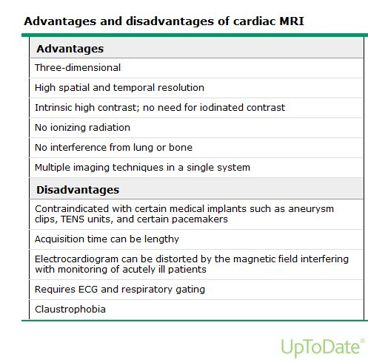
Slide 58 is text-empty; this table is its content. The trade is clean: no radiation, no iodine, no interference from lung or bone — against implants, time and claustrophobia. Titanium is acceptable. Source: Cardiac Imaging and Vascular Studies - Elwaya.pptx, Slide 58.

8.10 · Objective f.vi — Coronary angiography and the invasive studies
Coronary angiography gives detailed images of the coronary vessels and is the gold standard for coronary anatomy, usually done with cardiac catheterization and before percutaneous or surgical intervention. Under local anesthesia and sedation, a catheter is guided by fluoroscopy, pressures are measured, contrast is injected into each coronary artery, and treatment can be done in the same procedure (balloon angioplasty or stent).
Left heart catheterization | Right heart catheterization
Via an artery. Main use: the coronary arteries. Also aortic pressure, systemic vascular resistance, aortic and mitral valves, left ventricular pressure and function. | Via a vein. Main use: pulmonary hypertension. Right atrial, right ventricular, pulmonary artery and occlusion pressures, pulmonary vascular resistance, tricuspid and pulmonic valves, shunts.

Indications: to define a suspected problem when intervention is anticipated · to exclude significant disease when other studies are equivocal or symptoms are severe · high risk on noninvasive testing · angina despite therapy · unstable angina · acute infarction · high-risk non-cardiac surgery · arrhythmia suspected to be vascular.
NOTE
Complications at the access site — always check it: hematoma, and pseudoaneurysm (continuous communication with the artery; pulsatile).

Electrophysiology testing investigates and treats rhythm disorders: 3–4 catheters via the internal jugular, subclavian or femoral vein into the right heart record and provoke the arrhythmia to find its exact origin, and catheter ablation can treat it. Indications: syncope with structural heart disease or sick sinus syndrome, unexplained sudden cardiac arrest, ectopic beats, aberrant pathways.
Also tested
- Catheter ablation. During electrophysiological testing it inactivates part of the heart by destroying that tissue, not merely silencing it, which makes the treatment definitive.
- Coronary angiography. It is performed under local anesthesia with intravenous sedation, with catheters guided by fluoroscopy and contrast injected into each coronary artery; pressures are measured as the catheter goes, giving hemodynamic information alongside the pictures.
- Coronary angiography. It is the gold standard for coronary artery anatomy and cardiac function, which is why it is usually performed before any percutaneous or surgical intervention on the coronary arteries.

8.11 · Objective f.vii — Vascular ultrasound
Quartz crystals in the transducer send high-frequency sound; reflections become a grayscale image, superficial structures at the top. Denser is lighter (air black, bone white). Vessels appear as well-circumscribed hypoechoic or anechoic structures. On compression, veins collapse and arteries pulsate — a vein that will not collapse is the positive deep vein thrombosis study.
Indications | Advantages | Disadvantages
Vascular access · venous flow with Doppler; deep vein thrombosis · arterial: claudication and peripheral arterial disease · carotid: atherosclerosis, after stroke, transient ischemic attack or infarction · abdominal aortic aneurysm · venous insufficiency and varicose veins | Fast · cost effective · no ionizing radiation · noninvasive · real time · anatomy and flow · portable · repeatable | Highly operator dependent · body habitus · bone and air interfere · better for superficial vessels · probe angle affects measurements · calcification causes acoustic shadowing

Source: Cardiac Imaging and Vascular Studies - Elwaya.pptx (Ayelet Elwaya). Emphasis quoted from the 17 September 2026 recording (two segments). Slides 5, 36 and 58 carry their content only as pictures and are reproduced above. The nuclear perfusion panel on slide 52 is not reproduced: its six scans and three labels cannot be paired reliably from the file.
Also tested
- High-sensitivity troponin. High-sensitivity describes the assay's characteristics, not a different subunit of troponin; the assay detects circulating troponin at lower concentrations, which is where its advantage comes from.

9 · Cardiac Biomarkers and Lipid Testing
Lauren Reynolds, MSPA, PA-C · 21 September 2026
INSTRUCTIONAL OBJECTIVES
Topic Outline 9: Cardiac Biomarkers and Lipid Testing
- Compare and contrast cardiac biomarkers: i. Creatine kinase · ii. Cardiac troponins · iii. BNP · iv. hs-CRP
- Discuss indications for ordering cardiac biomarkers.
- Discuss indications for ordering a lipid profile.
- Analyze a lipid profile.
- Discuss the use of lipid testing for cardiovascular risk assessment.
- Compare and contrast lipids and lipoproteins involved in atherosclerotic disease.
- Describe measured and calculated lipid profile components.

NOTE
The one-line frame for the whole lecture. Cardiac biomarkers ask “is there acute cardiac injury or stress?” Lipids ask “what is the patient’s long-term atherosclerotic risk?” A 58-year-old with exertional chest pain gets biomarkers; a 58-year-old at a routine physical with abnormal cholesterol gets a lipid workup.
Numbers: every threshold below is here so you can read a result, not to memorize — reference ranges are supplied on her exams. One exception she drew in the recording: the adult LDL-C goal is not a lab range, so know its two ends (below).

★ PROFESSOR EMPHASIS
★ Professor emphasized — 21 September recording
She said | So
On slide 43’s Friedewald and non-HDL-C practice: “there will be two things that you need to calculate … for our purposes, we’re gonna practice this.” Then “You may use calculators,” and after the answers: “So we had to do two calculations, and then we have to interpret.” The newer equations are “more complicated. You can use a calculator for that.” [part 3, 6:03–9:48] | These two calculations are examinable: LDL-C = total − HDL-C − triglycerides ÷ 5, and non-HDL-C = total − HDL-C, then read each against the patient’s risk tier. Martin/Hopkins and Sampson are calculator-only. Unlike filtration rate and corrected sodium, which she ruled out in Lecture 5.
Asked whether a normal would always be given: there is no one normal, “so for this, you want to kind of have an idea of the difference between somebody who’s low risk and … high risk. So for LDL, if they’re low risk, less than 100 is our goal. If they’re high risk, less than 55.” [part 3, 10:36–11:04] | Know the LDL-C goal at each end: under 100 mg/dL for an average-risk adult, under 55 at the highest risk. The deck’s middle tier is under 70 (9.5). “Golf, not bowling”: the higher the risk, the lower the target.
“LDL is the big one that we care about … for risk stratification.” [part 3, 12:48] And for lipoprotein(a), which “is bolded for a reason” [part 2, 1:24]: “You can’t fix this with diet”; once in a lifetime; if it is high, “all of their first-degree relatives should be screened” — “cascading screening.” [part 2, 2:23–5:15] | Lipoprotein(a): genetic, measured once, cascade-test first-degree relatives, lifestyle does not lower it (9.6).
“When you hear CRP, think inflammation, period.” [part 1, 0:40] “When you hear BNP … think stretch and therefore volume.” [part 1, 2:07] “Troponin is your friend. When you’re worried about any kind of injury, any kind of ischemia to the heart, troponin is what you want to be ordering.” [part 1, 7:50] | The one-word frame for each marker: inflammation, stretch, injury.
“If you have troponin, don’t even waste your time ordering a CK.” [part 1, 31:05] Creatine kinase-MB only if troponin is unavailable; “you will absolutely order it” for rhabdomyolysis. [part 1, 15:58–16:26] | Creatine kinase is a skeletal-muscle test (9.2).
“Make sure you know what troponin you’re talking about when you’re reading your labs.” A conventional troponin I of 22 would be alarming; a high-sensitivity value of 22 is on a different scale. [part 1, 8:41–9:18] | Read a troponin against its own assay’s limit (slide 5 gives each).
Type 1 versus type 2 infarction (slide 11): type 1 is an occluded vessel, “take them to the cath lab”; type 2 is global supply failure (sepsis, hypoxia, blood loss) with a much milder troponin rise, treated by treating the cause. [part 1, 12:39–15:50] | A small troponin rise in a septic, hypoxic patient is expected; the height of the rise separates the two.
High-sensitivity C-reactive protein is “our risk stratifier … not part of your STEMI, acute coronary syndrome protocol. That’s an office visit type lab.” [part 1, 31:41–31:56] Above 50 mg/dL “is unlikely to be like a chronic inflammatory process” — that patient is septic. [part 1, 24:41] | Never the answer for acute chest pain; the answer for a well visit with a family history.
The chest-pain cases (slides 24–31): troponin and an EKG as soon as possible, plus a basic or comprehensive metabolic panel for kidney function, for “at least two reasons, probably three” — to interpret the troponin, because the catheter lab means contrast, and because diabetes and hypertension damage kidneys. Her milder, older patient: “do we think that just because her presenting symptoms are milder, that her labs are going to be better? Not necessarily.” [part 1, 33:27–38:58] | The next-best-test answer for acute chest pain is troponin + EKG, with renal function alongside. At follow-up she added hs-CRP, hemoglobin A1C and a repeat EKG.
Case 3 (slide 48, “diagnostic*”): “This person’s fine … So is this really diagnostic testing? Screening.” Order a fasting lipid panel, A1C, and a lipoprotein(a) if never measured. [part 3, 16:53–17:42] | The asterisk is the point: the same tests, ordered as screening. Family history of premature disease is also a fasting indication (9.3).

Where the slide and the recording differ. Four spoken statements differ from the deck; this guide teaches whichever is accurate. (1) She described trending troponin “every three hours through nine hours … zero, three, six, and nine” [part 1, 18:19]; slide 7 draws high-sensitivity troponin at 0 and 1–2 hours. Both are real protocols: the longer schedule belongs to conventional assays, the 0 and 1–2 hour one to high-sensitivity assays. (2) She called BNP “not super ideal for guiding therapy” and not for serial trending [part 1, 19:40–19:53]; slide 14 lists guiding therapy and monitoring the course as applications. She is closer to the evidence on therapy: adjusting treatment to the peptide level has not been shown to improve outcomes (2022 AHA/ACC/HFSA heart failure guideline), while tracking the course and stratifying risk are established uses. (3) She called type 2 infarction a “non-STEMI” and “injury” [part 1, 13:20; 30:38]; the deck’s own graph (slide 11) plots it as an infarction, and non-ST elevation is an electrocardiogram category, not a type. (4) For routine labs she would “just do fasting” [part 3, 15:02]; slide 46 says nonfasting is acceptable for most. Also loose: a high-sensitivity troponin of 22 is at, not under, slide 5’s male limit (under 22 ng/L).
Coverage. Three segments, about 80 minutes: part 1 (biomarkers and cases 1–2, from slide 4; the last eleven minutes are the break), part 2 (seven minutes on apolipoproteins and lipoprotein(a)) and part 3 (the lipid panel, the calculation, case 3). The opening minutes on slides 1–3 and the first lipid slides (32–33) fall outside the recordings.

9.1 · Objective a — Creatine kinase, troponins, BNP (B-type natriuretic peptide) and hs-CRP (high-sensitivity C-reactive protein)
Biomarker | Reflects | Source | Key use | Watch for
Creatine kinase (and its MB fraction) | Muscle injury; MB more cardiac | Cytosolic enzyme of skeletal and cardiac muscle | Largely historical for infarction; still used for rhabdomyolysis and statin myopathy | Low cardiac specificity; no longer useful for infarction when troponin is available
Cardiac troponin (I, T, high-sensitivity) | Myocardial injury/necrosis | Contractile regulatory proteins released with myocyte injury | Preferred marker for infarction; risk stratification | Most sensitive and specific cardiac marker, but rises in many non-infarction states (heart failure, pulmonary embolism, myocarditis, chronic kidney disease, sepsis)
BNP (B-type natriuretic peptide) / NT-proBNP (N-terminal pro B-type natriuretic peptide) | Wall stretch/stress | Ventricles, with volume or pressure overload | Diagnose and triage heart failure; prognosis in acute coronary syndrome | Raised by age, atrial fibrillation, renal impairment; suppressed by obesity
hs-CRP (high-sensitivity C-reactive protein) | Vascular/systemic inflammation | Acute-phase reactant from the liver | Adjunct risk marker for atherosclerotic disease | Non-specific; confounded by any inflammatory or infectious state

Also tested
- Troponin subunits. Troponin I, the inhibitory component, has cardiac specificity; troponin T is primarily cardiac, but trace amounts are detected in skeletal muscle.
- Troponin versus CK-MB. Troponin is preferred because it rises sooner and stays elevated longer, expanding the window for diagnosis and treatment, which matters for a patient presenting late.
- Serial natriuretic peptides. Beyond the rule-out, they monitor the course of disease and stratify risk, including cardiovascular mortality and likelihood of readmission; adjusting treatment to the peptide level has not been shown to improve outcomes.
- Natriuretic peptide as a rule-out test. A result below the assay's heart failure cutoff can serve to rule out new-onset heart failure, used together with the clinical assessment and an echocardiogram if indicated.

Troponin
Definition of acute infarction (Fourth Universal Definition): evidence of myocardial injury with troponin I or T above the 99th percentile upper reference limit, in the appropriate setting of ischemic symptoms. That limit is a value higher than 99% of a healthy population; exceeding it signals cardiac muscle damage and the need for further testing. Defining “healthy” is debated, but sex-specific limits are generally agreed.
Subunit | Role | As a biomarker
Troponin T | Tropomyosin-binding | Primarily cardiac; trace amounts in skeletal muscle
Troponin I | Inhibitory | Cardiac specific
Troponin C | Calcium-binding | Not useful — not specific to cardiac muscle

High-sensitivity troponin describes the assay, not a new subunit. It detects troponin at lower concentrations, allows serial testing at presentation and 1–2 hours, detects infarction up to 90 minutes earlier, and gives faster rule-in and rule-out. Pitfall: so sensitive that healthy people can have measurable levels — interpret with the whole clinical picture.
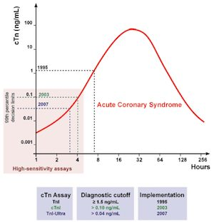
Slide 8 is only this picture. Each generation of assay lowered the diagnostic cutoff, and the lower the cutoff, the earlier the rising curve crosses it. That is the whole advantage of the high-sensitivity assay in one image. Source: svCardiac Biomarkers and Lipids.pptx, Slide 8.

Injury versus infarction
Myocardial injury = any troponin elevation. Myocardial infarction = injury plus ischemia plus a rising or falling pattern. Troponin can be chronically elevated in chronic kidney disease, heart failure and structural heart disease — never interpret a single value out of context.
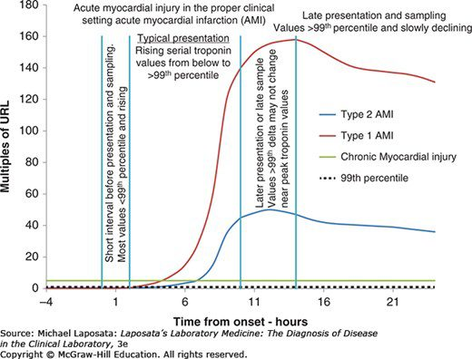
Slide 11 has no text; the graph is the teaching. Early presenters have values still below the limit and rising; typical presenters rise through it; late presenters sit near the peak, where the change between two draws may be small. The flat green line is chronic injury — above the limit but not moving. Source: svCardiac Biomarkers and Lipids.pptx, Slide 11.
Advantages over creatine kinase-MB: very high specificity for myocardial injury, earlier rise and longer elevation (a wider window for diagnosis and treatment), useful early risk stratification in unstable angina. No longer used for cardiac evaluation: creatine kinase-MB, myoglobin, lactate dehydrogenase.

The natriuretic peptides
Cardiomyocytes secrete pro-BNP in response to stretch; it is cleaved into active BNP (B-type natriuretic peptide) and inert NT-proBNP (N-terminal pro B-type natriuretic peptide). Neither is 100% specific for heart failure; neither is a stand-alone test — use with clinical assessment and an echocardiogram if indicated.
Factor | Effect on natriuretic peptide
Age | Rises by decade
Sex | Women higher
Obesity | Falsely low
Renal function | Inverse with filtration rate: worse kidneys, higher level

Reference ranges vary by assay (BNP cutoff is given as under 100 ng/L; NT-proBNP is age-stratified and based on renal function). Levels rise linearly with heart failure severity.

C-reactive protein
Rises quickly with inflammation and falls rapidly once it resolves. Raised by acute processes (plaque rupture, trauma), chronic ones (atherosclerosis, heart failure, acute coronary syndrome, autoimmune disease, diabetes, insomnia, obesity, cancer), mildly in women, older adults and smokers, and highest in bacterial infection. Lowered by NSAIDs (nonsteroidal anti-inflammatory drugs), statins, interleukin-6 receptor antagonists, GLP-1 (glucagon-like peptide-1) agonists and lifestyle change. Benefits: cheap, non-invasive, widely available including point of care, well researched, predictive. Pitfall: not cardiac specific.
C-reactive protein (general) | Typical meaning
Under 0.3 mg/dL | Normal
0.3–1.0 mg/dL | Normal or minor: obesity, pregnancy, diabetes, common cold, sedentary life, smoking
1.0–10.0 mg/dL | Moderate: rheumatoid arthritis, lupus, autoimmune disease, malignancy, infarction, pancreatitis, bronchitis
Above 10.0 mg/dL | Marked: acute bacterial or viral infection, vasculitis, major trauma
Above 50.0 mg/dL | Severe: generally acute bacterial infection

High-sensitivity C-reactive protein is a technique, not a different test: more precision at low levels, designed for healthy people, used for cardiovascular risk stratification. Level is directly proportional to risk; high levels are an independent risk factor for heart failure and cardiac mortality. Risk tiers (note the unit is mg/L): under 1 low · 1–3 moderate · above 3 high. It feeds the Reynolds Risk Score, a 10-year cardiovascular risk estimate for women over 45 (slide 21).

9.2 · Objective b — Indications for ordering cardiac biomarkers
Situation | Order
Suspected acute coronary syndrome / acute chest pain | Serial high-sensitivity troponin, first-line; look for a rising or falling pattern. The first value also carries prognostic weight.
Suspected heart failure / dyspnea triage | BNP (B-type natriuretic peptide) or NT-proBNP; also prognostic after acute coronary syndrome
Skeletal muscle injury, statin myopathy, rhabdomyolysis | Creatine kinase (not troponin)
Refining atherosclerotic risk in select primary-prevention patients | hs-CRP (high-sensitivity C-reactive protein) — never for acute diagnosis
When NOT to order | Routine natriuretic peptides in healthy people; creatine kinase-MB or myoglobin for infarction

Troponin applications: unstable angina (normal = no injury; raised = injury, so stratify and consider revascularization) · early rule-out and early rule-in, including small infarctions · risk stratification in acute coronary syndrome · infarct size (late elevation at 4 weeks is inversely related to left ventricular ejection fraction) · reocclusion and reinfarction · procedural infarction.
Procedural infarction | Troponin criterion
Type 4a (percutaneous coronary intervention) | More than 5 times the 99th percentile limit
Type 4b | At least one value above the 99th percentile limit
Type 5 (coronary artery bypass grafting) | More than 10 times the 99th percentile limit

Natriuretic peptide applications: rule-out of new heart failure · monitoring the course · risk stratification (cardiovascular mortality, readmission). Slide 14 also lists guiding therapy; titrating treatment to the peptide level has not been shown to improve outcomes, so learn it as the weakest of the four.
Key points from the deck, in one breath. Troponin is the marker of choice for necrosis. Injury is not infarction. Creatine kinase-MB and myoglobin add nothing once troponin is available. Troponin can be chronically raised. BNP reflects stretch, not injury — complementary to troponin. hs-CRP is a risk enhancer, not an acute test.
Also tested
- Troponin beyond first diagnosis. Troponins also detect reocclusion and reinfarction, and procedure-related infarction, such as returning chest pain after a stent.

9.3 · Objective c — Indications for ordering a lipid profile
Why: baseline documentation, atherosclerotic risk estimation, and guiding or monitoring lipid-lowering therapy — in nearly all adults.
Question | Answer
Fasting or not? | Nonfasting is acceptable for most. Fasting when triglycerides are 400 mg/dL or above, a triglyceride disorder is known or suspected, or there is a family history of premature atherosclerotic disease or genetic dyslipidemia.
Children | Screen at ages 9–11; from age 2 with a family history of premature disease, severe hypercholesterolemia or familial hypercholesterolemia
Adults | Again at 19, then roughly every 5 years, more often with risk factors
On therapy | Recheck 4–12 weeks after starting or changing a dose, then every 6–12 months
Lipoprotein(a) | Measure at least once in all adults

Also tested
- Apolipoprotein B monitoring. It is a modifiable, treatment-responsive marker, so it is used repeatedly to guide and monitor lipid-lowering therapy, unlike lipoprotein(a), which is fixed and measured once.

9.4 · Objective d — Analyzing a lipid profile
Component | Measured or calculated | Desirable / lower risk | Actionable
Total cholesterol | Measured | Under 200 mg/dL | Very high values raise familial hypercholesterolemia scoring
LDL-C (low-density lipoprotein cholesterol) | Calculated | Risk-based goal: under 100, 70 or 55 mg/dL | 190 mg/dL or above: statin regardless of risk; evaluate for familial hypercholesterolemia
Non-HDL-C (non-high-density lipoprotein cholesterol) | Calculated | Risk-based goal: under 130, 100 or 85 mg/dL | Tracks with the LDL-C goals
HDL-C (high-density lipoprotein cholesterol) | Measured | Higher generally favorable | A marker, not a treatment target
Triglycerides | Measured | Under 150 mg/dL | 150+ risk enhancer · 500+ severe, pancreatitis risk · 1000+ extreme
ApoB (apolipoprotein B) | Measured | Under 90 (goal under 70 or 55 by tier) | Use with triglycerides 150+, diabetes, or LDL-C under 70 to find residual risk
Lipoprotein(a) | Measured once | Under 125 nmol/L (about 50 mg/dL) | 125+ risk enhancer · 250+ about double risk · 430+ comparable to heterozygous familial hypercholesterolemia

NOTE
The teaching point on this table: adult LDL-C and non-HDL-C have no single normal value — the goal depends on the patient’s risk tier — whereas triglyceride, apoB and lipoprotein(a) thresholds are more fixed. An elevated lipoprotein(a) is found in about 20% of people, with about 40% higher relative risk. Lipoprotein(a) and apoB share a panel because each lipoprotein(a) particle adds to the apoB count.

NOTE
The deck states the lipoprotein(a) doubling point two ways. Slide 40: 250 nmol/L (about 100 mg/dL) or above is 2 or more times the risk. Slide 44: about 80–100 mg/dL roughly doubles risk. Neither is worth memorizing, and no question here turns on which is right.

Pediatric (mg/dL) | Acceptable | Borderline | Abnormal
Total cholesterol | Under 170 | 170–199 | 200 or above
Triglycerides, 0–9 years | Under 75 | 75–99 | 100 or above
Triglycerides, 10–19 years | Under 90 | 90–129 | 130 or above
HDL-C | Above 45 | 40–45 | Under 40
LDL-C | Under 110 | 110–129 | 130 or above
Non-HDL-C | Under 120 | 120–144 | 145 or above

Also tested
- Non-HDL-C. It equals total cholesterol minus HDL-C (210 minus 50 is 160 mg/dL), is followed against a risk-based goal, and needs no triglyceride value and costs nothing extra.
- Favorable lipid profile. Total cholesterol below 200 mg/dL and triglycerides below 150 mg/dL, with a high HDL-C, is generally a favorable profile.
- Triglyceride level and risk. Triglycerides of 150 mg/dL or above mean increased atherosclerotic risk and act as a risk enhancer for atherosclerotic disease; severe hypertriglyceridemia begins at 500 mg/dL.

9.5 · Objective e — Lipid testing in cardiovascular risk assessment
Lipid values feed a 10-year atherosclerotic risk estimate — the PREVENT (Predicting Risk of cardiovascular disease EVENTs) equations in the 2026 guideline — and the estimate drives treatment intensity. The framework is Calculate → Personalize → Reclassify.
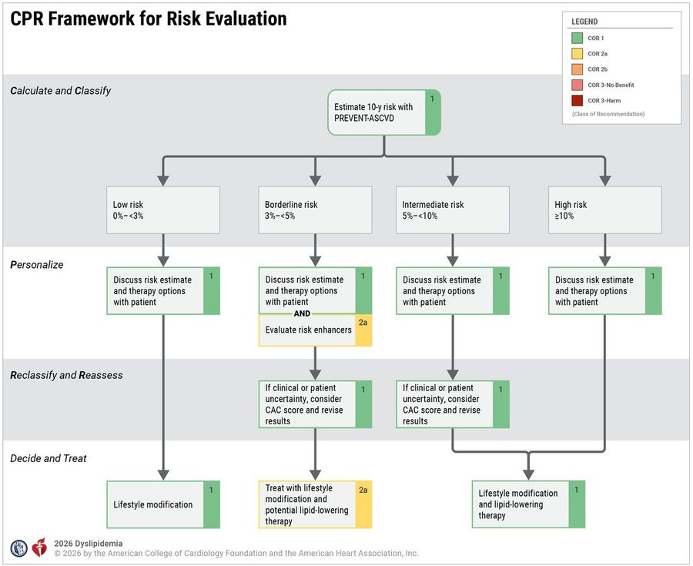
The four tiers and what each adds. Low under 3% · borderline 3 to under 5% (add risk enhancers ) · intermediate 5 to under 10% · high 10% or above. When the clinician or patient is uncertain at borderline or intermediate risk, a coronary artery calcium score reclassifies. Source: svCardiac Biomarkers and Lipids.pptx, Slide 50.
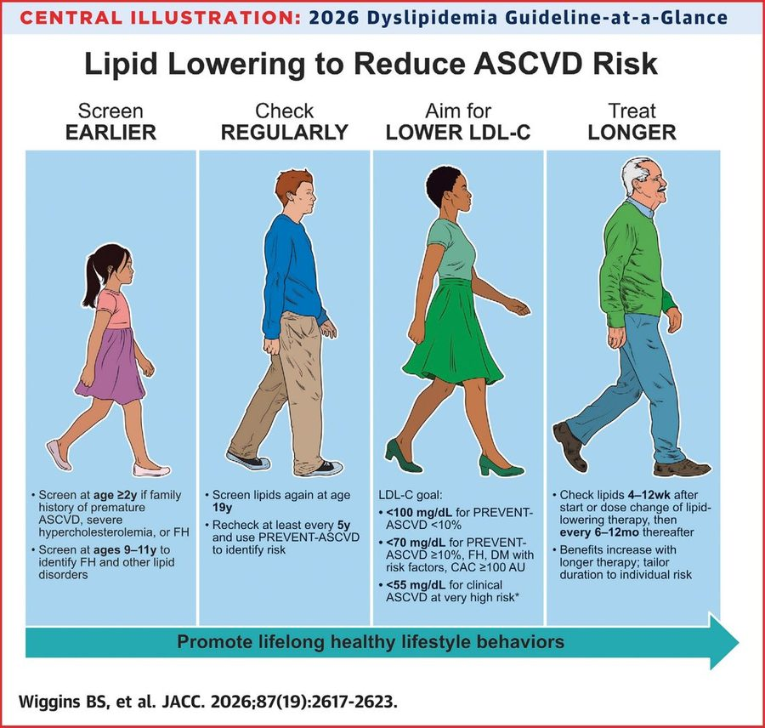
Screen earlier, check regularly, aim lower, treat longer. The LDL-C goals: under 100 mg/dL if PREVENT risk is under 10% · under 70 if 10% or above, familial hypercholesterolemia, diabetes with risk factors, or coronary calcium 100 or above · under 55 for clinical atherosclerotic disease at very high risk. Source: svCardiac Biomarkers and Lipids.pptx, Slide 49.
Lipoprotein(a) in risk assessment: a largely fixed genetic factor measured once. Elevation prompts earlier and more intensive management of every other modifiable risk factor — statins do not lower it. ApoB, by contrast, is modifiable and used repeatedly to guide and monitor therapy.
Also tested
- Fasting for a lipid profile. Nonfasting samples are acceptable for most people. Fasting is reserved for triglycerides of 400 mg/dL or above, triglyceride disorders, or a family history of premature disease or genetic dyslipidemia.
- Childhood lipid screening. A lipid screen is indicated at ages 9 to 11, even without a family history, to identify familial hypercholesterolemia and other lipid disorders; lipids are screened again at 19.
- Rechecking lipids after starting therapy. Check lipids in 4 to 12 weeks after starting or changing the dose of lipid-lowering therapy, then every 6 to 12 months.
- Early lipid screening with a family history. Screening at age 2 or older is recommended with a family history of premature atherosclerotic disease, severe hypercholesterolemia or familial hypercholesterolemia.

9.6 · Objective f — Lipids and lipoproteins in atherosclerosis
Cholesterol and triglycerides are the major lipids; they are insoluble and travel inside lipoproteins. A lipoprotein = lipid core (cholesterol esters + triglycerides) + phospholipid shell + apolipoproteins.
Lipoprotein | Main cargo | Apolipoprotein | Atherogenic?
Chylomicron | Dietary triglyceride | apoB-48 | Remnants are
VLDL (very low-density lipoprotein) | Triglyceride | apoB-100 | Yes (remnants)
IDL (intermediate-density lipoprotein) / remnants | Cholesterol + triglyceride | apoB-100 | Yes
LDL (low-density lipoprotein) | Cholesterol | apoB-100 | Yes — principal driver
Lipoprotein(a) | Cholesterol + apo(a) | apoB-100 + apo(a) | Highly atherogenic; genetic
HDL (high-density lipoprotein) | Cholesterol | apoA-I | No — reverse cholesterol transport (protective)

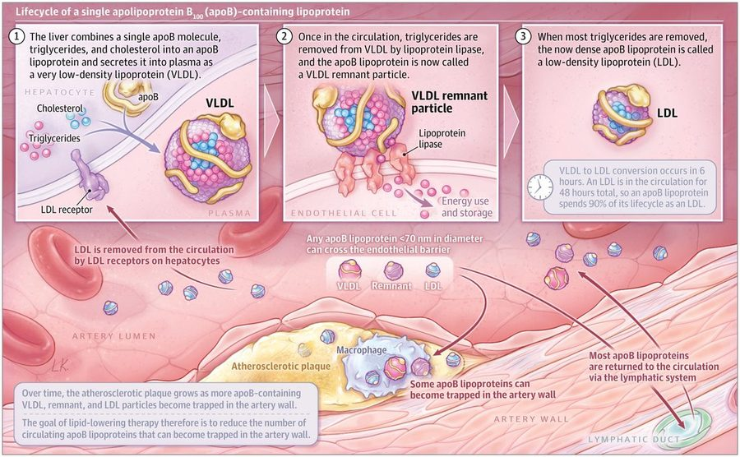
One particle, three names. VLDL (very low-density lipoprotein), remnant and LDL (low-density lipoprotein) are the same apoB particle at different stages. Any apoB particle under about 70 nm can enter the artery wall and be trapped there, which is why the goal of therapy is fewer circulating apoB particles. Source: svCardiac Biomarkers and Lipids.pptx, Slide 33.
Apolipoprotein | Made by | Found on / role
ApoB-48 | Intestine | Chylomicrons
ApoB-100 | Liver | VLDL (very low-density), IDL (intermediate-density) and LDL (low-density lipoprotein), and lipoprotein(a) — one per particle; not in HDL
ApoA-I | Liver and intestine | Major structural protein of all HDL
ApoA-II | — | Second most abundant HDL protein; on about two-thirds of HDL
ApoC, apoC-III, apoA-V | — | Regulate triglyceride metabolism
ApoE | — | Critical in triglyceride clearance
Apo(a) | — | Forms lipoprotein(a)

Lipoprotein(a) is an LDL-like particle with apo(a) bound to apoB-100: more than 90% genetic, stable over life, no fasting, one lifetime measurement generally enough. Repeat is reasonable in women after menopause if the earlier level was borderline. Test anyone with a personal or family history of atherosclerotic disease, with cascade testing through appropriate families. It is statin-resistant and more atherogenic than LDL.
LDL is the major cholesterol carrier and the primary prevention target; LDL-C and risk have a log-linear relationship. Remnant cholesterol and triglyceride-rich lipoproteins carry residual risk.
Also tested
- Lipoprotein(a) testing. The level is more than 90% genetically determined, so testing is indicated with a personal or family history of atherosclerotic disease and extends to first-degree relatives through cascade testing in appropriate families.
- Lipoprotein(a) measurement. It generally needs measuring once in a lifetime: it is more than 90% genetically determined and stable over life, and needs no fasting.
- Formation of LDL. The liver secretes triglyceride-rich VLDL (very low-density lipoprotein); lipoprotein lipase strips triglyceride to give a remnant (IDL, intermediate-density lipoprotein) and then cholesterol-rich LDL (low-density lipoprotein), the same apolipoprotein B particle at different stages.

9.7 · Objective g — Measured and calculated components
Measured directly | Calculated
Total cholesterol, HDL-C, triglycerides (and apoB, lipoprotein(a) when ordered) | LDL-C — an estimate, not a measurement, on a standard panel · non-HDL-C

Estimate | How | Note
Friedewald LDL-C | Total cholesterol − HDL-C − (triglycerides ÷ 5) | Cannot be used when triglycerides are 400 mg/dL or above
Martin/Hopkins or Sampson/NIH (National Institutes of Health) | Newer equations | Preferred, especially with triglycerides 150+ or low LDL-C
Non-HDL-C | Total cholesterol − HDL-C | Captures every atherogenic apoB lipoprotein; no added cost; a better predictor than LDL-C; recommended for routine reporting

NOTE
Worked the way the deck’s own practice slide asks. A panel with total cholesterol 200 mg/dL, HDL-C 50 mg/dL and triglycerides 100 mg/dL: non-HDL-C = 200 − 50 = 150 mg/dL; Friedewald LDL-C = 200 − 50 − 20 = 130 mg/dL. This arithmetic is examinable: she worked slide 43 in class as “two calculations, and then … interpret” (178 − 62 − 18 = 98; 178 − 62 = 116; both in range for a low-risk patient, “not even close” for a high-risk one). Triglycerides of 400 mg/dL or more: “we cannot trust that calculation.”

Source: svCardiac Biomarkers and Lipids.pptx (Professor Lauren Reynolds). Slides 8 and 11 carry their content only as pictures and are reproduced above; slide 21 (the Reynolds Risk Score) is a screenshot of a calculator whose inputs are listed in 9.1. The worked cases on slides 24–31 and 47–48 are teaching scaffolds and are not restated. Emphasis quoted from the 21 September 2026 recording (three segments), read in both transcripts.

